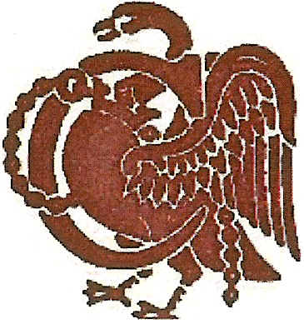

**Buckinghamshire Lady Captains’**

**Golfing Society**

Founded 1983

|  |  |
| --- | --- |
| **Hon Secretary - Ms Luisa Borrego** | **Lady Captain – Mrs Gill Redman** |
| 26 Kite Wood Road,  Penn,  Bucks  HP10 8HH  01494 816746  Lmdb53@outlook.com | 3 Idaho Park,  Prestwood,  Bucks,  HP16 0UJ  01494 863935  [Gillredman232@btinternet.com](mailto:Gillredman232@btinternet.com) |

Dear Member,

**ANNUAL SUBSCRIPTIONS RENEWAL**

2022 annual subscriptions are now due; **payable no later than 23rd March 2022.**

If your subscription is not received by this date, it will be assumed that you do not wish to renew your membership. Reminders will not be sent.

**Playing Members £12.50** **Social Members £3.00**

**……………………………………………………………………………………..……..……………………….**

**ANNUAL MEMBERSHIP RENEWAL FORM**

**Please make cheques payable to BLCGS** - **send to Ms Luisa Borrego at the above address**

**OR**

Pay directly into our bank account at Natwest Bank Sort Code 60-17-43 Account 70330360 adding reference SUB and your full name **and email this completed form to the Secretary at lmdb53@outlook.com**

**Subscriptions: PLAYING MEMBER £12.50 £**..................

**SOCIAL MEMBER £ 3.00 £**.................

**FOUNDER MEMBER £ 0.00** please tick

Name .... Tel.No..........................................................

E-mail address…………………………………………………………………………………………...

Present Club... …………………………………Club of Captaincy…………………………..

Current handicap Index CDH Number ……………………………………

I consent for BLCGS to hold my personal details YES / NO

Please fill in all sections of this form so the society can keep their records updated, thank you.