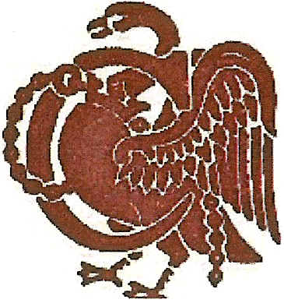

**Buckinghamshire Lady Captains’**

**Golfing Society**

Founded 1983

|  |  |
| --- | --- |
| **Hon Secretary - Ms Luisa Borrego** | **Lady Captain – Mrs Gill Redman** |
| 26 Kite Wood Road,  Penn,  Bucks  HP10 8HH  01494 816746  [Lmdb53@outlook.com](mailto:Lmdb53@outlook.com) | 3 Idaho Park,  Prestwood,  Bucks,  HP16 0UJ  01494 863935  [Gillredman32@btinternet.com](mailto:Gillredman32@btinternet.com) |

**D**ear Member,

**AGM & Annual Luncheon at Harleyford Golf Club.**

The Annual General Meeting of the BLCGS will take place at Harleyford Golf Club on Wednesday 23rd March 2022 **after the Spring Meeting**

The first tee time for the Spring Meeting is at 8.30am and lunch, a rolling carvery, served from 13.30pm.

The AGM will start during dessert which we estimate to be about 3pm.

The annual lunch, which is optional, will be served from 13.30pm, at a cost of £25 per person, and the closing date is 10th March 2021. A raffle to raise money for the Lady Captain’s Charity will be held. (It will not be necessary for clubs to provide a raffle prize.)

**…………………………………………………………………………………………………………………**

**A.G.M. & ANNUAL LUNCH APPLICATION**

Please make cheques payable to BLCGS & send to the Hon. Secretary: - Ms Luisa Borrego at the above address **OR** pay directly into our bank account at Natwest Bank Sort Code 60-17-43 Account 70330360 adding reference AGM and your full name

**and email this completed form to the Secretary at lmdb53@outlook.com**

**LUNCH & AGM.** **£25.00**   **AGM MEETING ONLY** (no cost)

Name .... Tel.No..........................................................

Email address ……………………………………………………………………………………….

Please indicate dietary requirements………………………………………………………………..…